ELEMENT D - The solution
Are final solution was to get a bigger bag make the blow dryer a smaller version so we don't use that much plastic from such a little problem
To bring our project to life, the group will need some fruits (strawberries, blueberries, etc), a ziploc bag, a small coffee cup, a straw, and a blow dryer. First, we will put our fruits in the ziploc bag, and zip it up until there is a space small enough to insert the straw. Then, we grab the cup, create a small incision, slide one end of the straw into it, and then put the free side of the straw in the gap of the ziploc bag. When those steps are finished, we have to plug in the blow dryer, turn it on, and then put the end of it into the cup, and the ziploc bag should flatten, showing that all of the air has exited the bag.
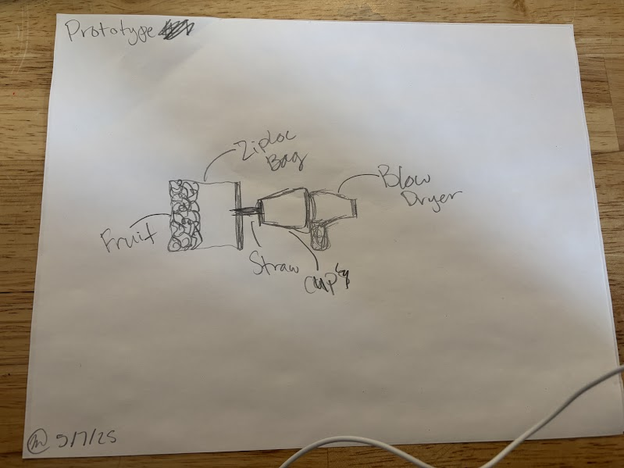
We need ziplock bags and a blow dryer and fruit

ELEMENT E - Concept
We used scientific research to find the problem, how does vacuum sealing help fix the problem
Our expert said that we should use the proper materials since we didn’t have everything we needed. The materials we did not have were an actual fruit, a straw, and a cup.
Our experts know a lot about how long food lasts and how to store it safely at home. They are trained to help people make smart food choices, including how to keep food fresh. They are helpful because they work with families and individuals every day and understand the challenges people face when trying to reduce food waste.

ELEMENT F - How our solution works
This will address the stakeholders problem by making them a solution: a ziploc bag to seal food, the features that we used for household items.

